Updated App Specification

The updated purpose of this application is to ease the process of going to the gym and planning workouts for newcomers and gym veterans alike by giving them access to a plethora of exercises. The application’s main function will allow users to look through exercises and choose these for their own workout regimes to fit their needs, also giving them a gym alarm clock to ensure they go to the gym on time and even send reminders to their gym partners.

The application can show what movements users can do and show the recommended form and procedure of doing said exercises with any tips they may require on the way.

As mentioned earlier, the user can use a gym alarm, which detects the state and time zone the phone is in and sets a timer for a notification to pop up at the time the user would like to be reminded to go to the gym. Along with this, the app has a dedicated button to messaging and gym partners or friends to also accompany them on their gym journey.

Functional spec:

Interface: The interface utilizes a range of buttons with symbols or words with appropriate layouts on each page. Screen orientation is be supported for when the user rotates their screen.

Alarm: Users have access to a gym alarm and can remind themselves when to go to the gym

Accounts: Users can create and login using accounts to allow users to save their user theme settings and alarms.

Database: This stores account details via Google firebase and allows easy registration.

Navigation: The application will have a range of menus that will be easy to navigate through and provide users with an easy user interface designed to keep them motivated throughout. A menu on the bottom of the screen will be created to allow users to navigate through the different pages with ease. Interactivity wise, the user will be able to swipe through the choice of gym exercises.

With this app users can:

* Browse exercises
* View exercise description
* Switch between dark and light themes
* Find their nearest gym
* View the user guide
* Receive notifications and reminders to workout
* Access these exercises in landscape or portrait, along with tablet support
* Manage app permissions

Future enhancements and improvements:

* Addition of workouts
* Like and share regimes
* Create, edit, and delete a regime
* Browse through created regimes
* Type and add to gym diary
* Swipe through and view gym diary pages
* Follow and unfollow users
* Like and dislike public regimes that others have created
* Save regimes for later use
* Feedback form support on website

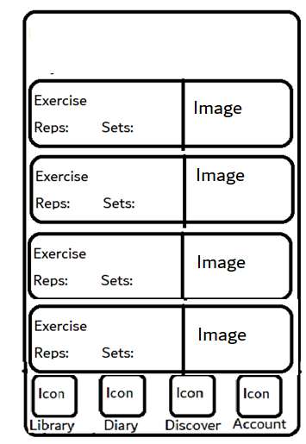

This page is displayed when the discover page is tapped

1 – Exercise panel

2 – Swipe up and down

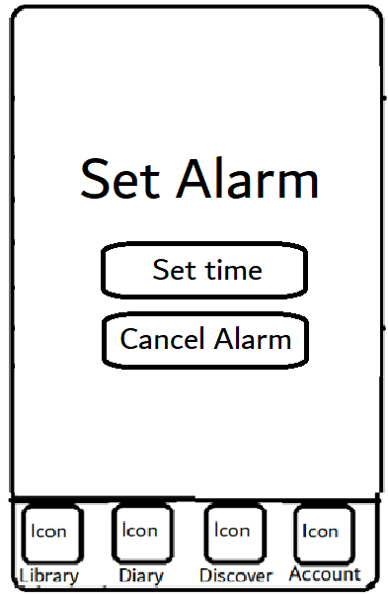

This page is displayed when the user is on the alarm page

1 – Displays the alarm state

2 – Set alarm timer

3 – Cancel the alarm